Interview with Madeleine Beard
by Jack Carrigan

The Catholic Herald, 18th December 2008
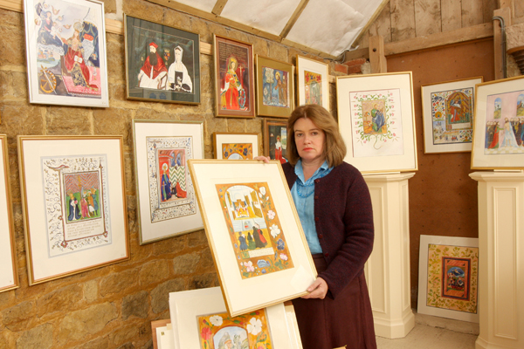
Fighting in the trenches during the Great War, a young Englishman, Vincent Beard, happened upon an obscure novel about a Portuguese Franciscan, entitled Antonio. Reading it alongside letters from his sister Beatrice, a convert, brought Vincent and his wife into the Church in 1919. He was the grandfather of the watercolour icon painter, Madeleine Beard. Talking to her, it is evident that her love for her faith as well as her artistic gifts flow in part from her family. Her father was very devout and he also painted; in her private gallery, a converted barn on the family farm, she has exhibited his paintings as well as her own.

Influenced by meeting the economist, Barbara Ward, she studied Geography at UCL before doing an M. Litt. at Jesus College, Cambridge on the impact of WW1 on rural Sussex society. A chance discovery in Cambridge University Library of a book listing converts to Rome between 1850 and 1910 led to her writing Faith and Fortune, a study of the lives of these influential men and women: “I was struck by their generosity and single-mindedness. They contributed so much to the life of the Church in their time.”

At UCL she had begun to attend daily Mass; at Cambridge, coming into contact with the then chaplain, Dom Christopher Jenkins OSB, who had been one of Mgr Gilbey’s student converts, she attended Mass in the Tridentine form for the first time. This proved a turning point for her art and her historical interests. I ask her to explain how and why and she slowly formulates an answer. “Whether one is a musician or an artist, I believe one’s concentration and creativity must flow from concentration at Mass. By our nature we are easily distracted. The liturgy in the traditional form focuses the senses on the Sacrifice - through Gregorian chant, the drama of the moment of consecration, the liturgical vestments, incense and above all, the silence.” As we talk we are walking down a bustling, crowded, pre-Christmas street in Oxford, surrounded by shoppers, traffic – and noise. I picture my companion bending over her work in her studio, paintbrush in hand, deep in the Sussex countryside where she lives, absorbing the silence that accompanies creative work.
How did her own artistic vocation develop? “I am not really a scholar or academic,” she replies modestly, “and I didn’t want to spend my life in libraries. I had always painted, like my father, though I have never had any artistic training as such. Then, on a pilgrimage to Poland in 1993, I became influenced by icons and the revival of the Church in central Europe after the fall of Communism. Now I am painting what I would describe as Western icons in an English way, adapting the English watercolour tradition for this purpose.”

She shows me some samples of her art from her portfolio: a combination of tiny, jewel-like details, iconic lack of perspective and vibrant colour. “They remind me of medieval Books of Hours,” I suggest. She agrees; “I am inspired by drawing on the imagination of medieval artists for whom religious imagery – sacraments, feasts, saints’ days – was a constant theme.” She is much in demand for commissions. In 2007 her painting of St Helena was placed in the Holy Cross Church, Seaview, on the Isle of Wight, to commemorate the 50th anniversary of the church’s foundation; more recently a friend has requested her to paint the saints of all her family’s names, unusual but lovely gifts that she wishes to leave them in her Will.

Madeleine’s devotion to the Extraordinary form and Catholic history have combined in a further direction. A chance meeting with John and Liz Wetherell at the Carthusian monastery of Parkminster led to her setting up the St Joan Press in 2005. So far two books, beautifully bound and produced, illustrated by her, have been printed: Lex Orandi Lex Credendi by Wetherell and more recently, Reginald Cardinal Pole, written by Michael Hutchings. Pole died within hours of Mary Tudor, on 17 November 1558 and she is delighted that the 450th anniversary of his death was recently commemorated by Requiem Masses in Oxford, Cambridge, London and Birmingham. “I had read a book about him and thought what an extraordinary person he was. He is a central figure in English Catholic history but there is a sense in which he is unknown to modern Catholics.” “Why?” I ask. “Well, he wasn’t martyred, for one thing, and he also spent so much of his life in Italy” is her view.

Chance, I venture, has played quite a large part in her life and she smiles; one feels that any random event or meeting contains the possibility of a spiritual and cultural renewal of faith. For her, the phrase “the conversion of England”, implicit in the “Prayer for England” always said at Benediction, is not simply a pious hope that should not be mentioned at ecumenical gatherings; it is a dynamic imperative to be pursued by all Catholics, lay and clerical, through whatever gifts at their disposal. “We are here to spend our lives meditating on our faith”, she tells me with some asperity, adding “I believe the faith is caught, not taught.” But what about Mgr Gilbey’s conferences to teach Cambridge undergraduates the faith, influenced by Mgr Ronald Knox’s similar conferences for Oxford students, and which resulted in a book she much admires, We Believe? The artist in her wants to demur; the writer and researcher concedes there might be an interaction between the mind and grace.

I mention an encounter – “clash” might be more accurate - she once had at a public function where Baroness Thatcher was speaking. She is self-deprecating about it but to me it shows that behind her courteous, quiet and understated English demeanour is a woman of courage and strong conviction. After the speech she engineered it so that she was standing in front of the Iron Lady. She told her that one could not talk of justice and freedom without mentioning the unborn. Lady Thatcher began, “We do know that after 6 weeks...” She interrupted, saying that life began at the moment of conception. Lady Thatcher began to make a distinction between the “biological” and the “theological” approach. Nothing daunted she reiterated, “They both contain the word “logical” and it is logical to say that life begins the moment of conception.” To this the Baroness retorted that neither of them would want to give birth to a handicapped child. Madeleine pointed out that she was discriminating against all handicapped people, including those who became disabled through illness or accident, adding, “What is more, we cannot afford to lose 500 children every day. This country, Europe, is dying out.” “No, it isn’t!” “Yes, it is!” “No, it isn’t!” “Yes, it is!”

I am not surprised that Madeleine Beard had the last word in this memorable and barbed encounter. Like St Joan of Arc, patron of her publishing venture, she can be combative when necessary. Pope Benedict has recently spoken of a need for “a renewed dialogue between aesthetics and ethics.” In her public witness and in her artistic work Madeleine Beard manages to combine both.

Jack Carrigan

